**MonkeyType.com**

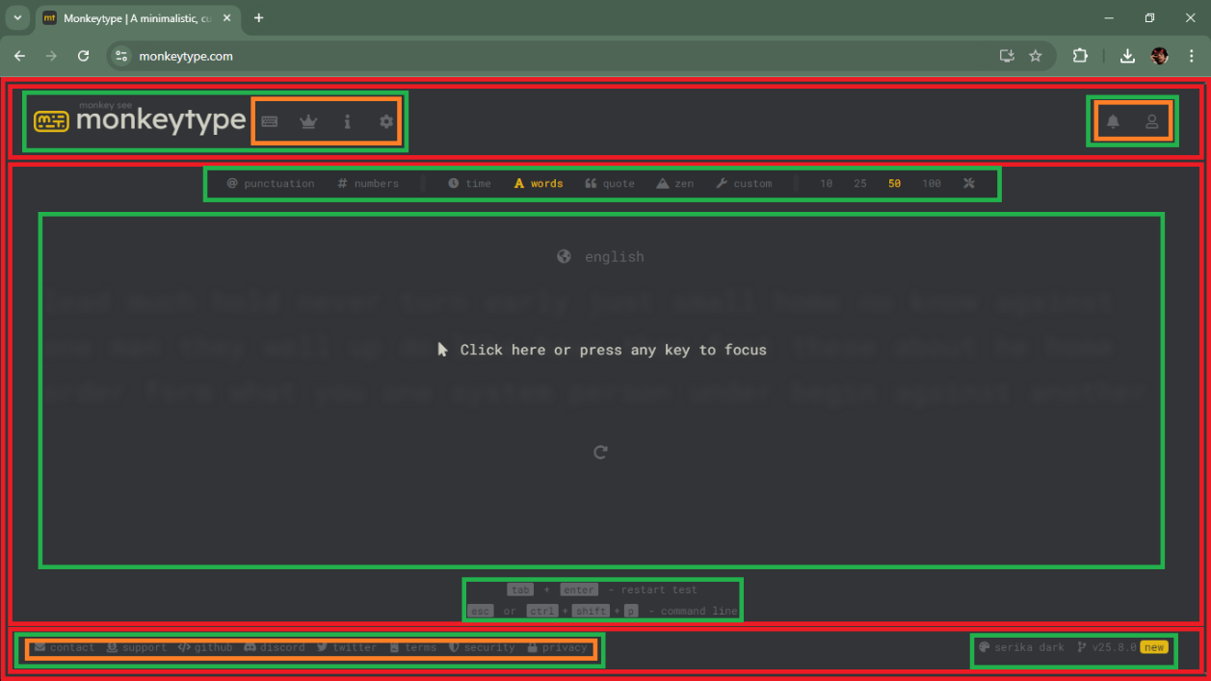

**ROW FOR THE NAV**

**NOTIFICATION, ACCOUNT INFORMATION / LOG IN and USER PROFILE**

**ROW FOR THE NAV**

**START TYPING, LEADERBOARDS, ABOUT and SETTINGS.**

**ROW FOR SOCIALS, FEEDBACKS and SECURITIES**

SHORTCUT KEY OR COMMAND LINE

THEME AND VERSION

CHALLENGE AREA

ROW FOR THE CHALLENGES OPTION AND TIMER

**LOGO WITH TITLE**

NAVIGATION BAR

HEADER

FOOTER

**BODY**

MAIN

**ANALYSIS**

When I started analyzing the website’s structure, the first thing I did was look for the biggest section, which is the body the main content area with some noticeable padding. After that, I broke the layout down into three main parts: the header, body, and footer. Since Monkeytype.com has such a simple and minimalist UI, I pretty much figured it out after just seeing it once.

The header contains the navigation bar, logo, and user-related options, making it easy to access different features. The body is the main focus of the site, where the typing challenge happens. Meanwhile, the footer is smaller but still important, with social links, feedback options, shortcut keys, and theme/version details.

What I like about this site is how clean and distraction-free it is. Everything is laid out clearly, and there’s no clutter just a smooth and simple experience that lets users jump straight into typing.

https://github.com/Kannnneee/ARMADA_LOGICS/tree/0f575dc64c46ab5d830b4b48e5b36b03515b4e6e/Think%20in%20Boxes